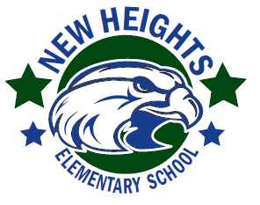
New Heights Elementary
ADOPT-A-CLASS PROGRAM

Yes! I would like to Adopt-A-Class for the 2019-2020 School Year!
Please accept my donation in the amount of $ ______________________ for the Adoption of the following class/classes or programs: (Please specify amounts if adopting more than one class or program).

- ESE/VPK | Teachers Name:
- Pre-K Autistic | Teachers Name:
- Kindergarten | Teachers Name:
- 1st Grade | Teachers Name:
- 2nd Grade | Teachers Name:
- 3rd Grade | Teachers Name:
- 4th Grade | Teachers Name:
- 5th Grade | Teachers Name:
- ASD Classes | Teachers Name:
- Media Center | - Art | - Speech Therapy
- Technology Lab | - Music | - Occupational Therapy
- Physical Education | - Positive Behavior Support | - Physical Therapy
- Safety Patrols | - STEM | - Staff Appreciation
- Waterway
- Landscaping

Please check one:
- If funds are not spent during the 2019-2020 school year, I agree to allow the teacher to retain the funds for the following school year.
- Any funds remaining at the end of the 2019-2020 school year shall be transferred to the Adopt-A-School account which shall be used at the discretion of the Principal and will be used to benefit the student body as a whole.


Signature: ________________________________________________________________________________________

Name: ___________________________________________________________________________________________
Business: _________________________________________________________________________________________
Phone and/or email: _________________________________________________________________________________
Please make your checks payable to New Heights Elementary.
Checks can be mailed to 13901 37th St N, St Petersburg, FL 33714
If you have any questions, please contact our School Bookkeeper at 727.521.5350 Ext 2005.

We are confident that you will find our program a worthwhile investment for yourself, your organization and most importantly, the students.
Thank you for your support!

